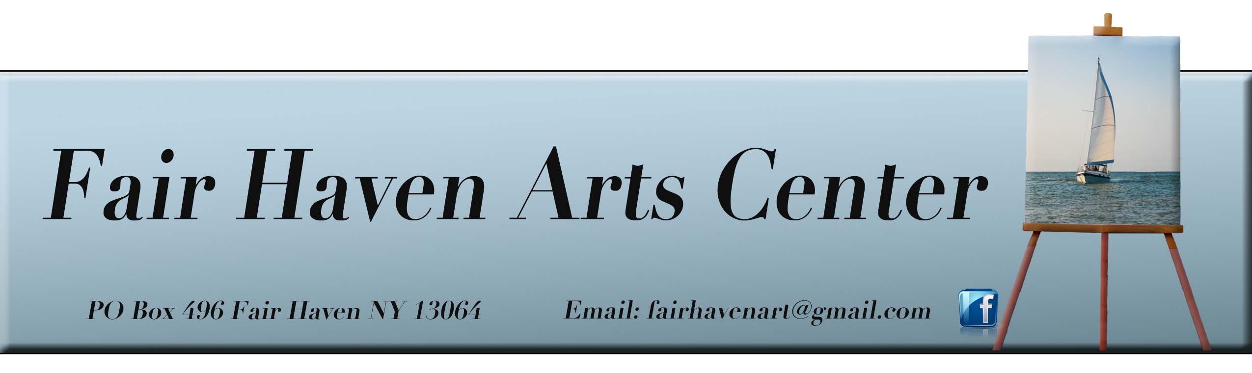
GIFT CERTIFICATE PURCHASE FORM
Fair Haven Community Arts Center’s purpose is to enhance the arts in the greater Fair Haven community, to facilitate education in the arts for all ages and abilities, to create opportunities for professional and economic development of local artists and to create a center for the advancement of these purposes. Your support will help bring this vision to reality, allowing us to enhance the lives of those who live and work in our community for generations to come.

Gift certificates are redeemable toward any class held at the Fair Haven Art Center. The certificates are good for one year. Please enter below the amount of each certificate you are requesting.

- Gift certificate amount: $______________
- Gift certificate amount: $______________
- Gift certificate amount: $______________
- Gift certificate amount: $______________
- Gift certificate amount: $______________

Purchaser Information: (we will mail your gift certificate(s) once payment has been processed) You may also arrange pickup by emailing us or leaving a message at
315-947-2144.
Date Submitted:_____________

Name:

Address: ________
Email: __________________________________
Phone: Cell: ________

PAYMENT: Cash ___Check___ Credit Card___ DO NOT include your card number.
You will be invoiced through our PayPal account.

Mail form and check to:
Fair Haven Arts Center
PO Box 496
Fair Haven, NY 13064
www.fairhavenarts.org

