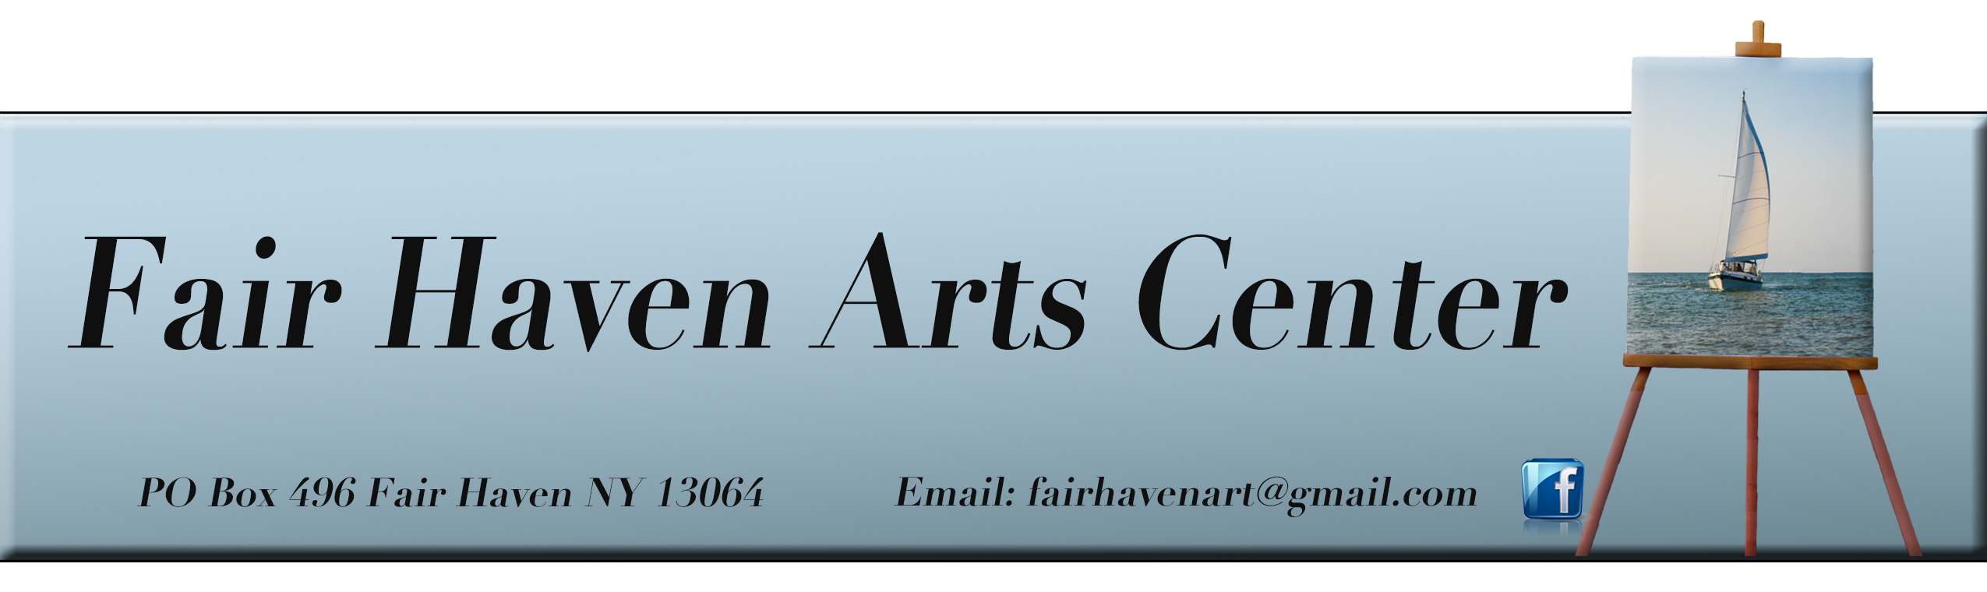
MEMBERSHIP FORM – June 1, 2020 – May 31, 2021
Fair Haven Community Arts Center’s purpose is to enhance the arts in the greater Fair Haven community, to facilitate education in the arts for all ages and abilities, to create opportunities for professional and economic development of local artists and to create a center for the advancement of these purposes. Your support will help bring this vision to reality, allowing us to enhance the lives of those who live and work in our community for generations to come.
Members enjoy a special sense of belonging to the local arts community. By joining the FHCAC today be the first to hear about upcoming events and programs, receive discounts for classes and art show submissions, and help to promote growth of the arts in our community. We hope you will agree that a modest cost is well worth the benefits we plan to bring to our community.
PLEASE CHECK THE MEMBERSHIP LEVEL OF YOUR CHOICE -- Date submitted:_____________
Student $15.00
Senior (62+) $20.00 ______
Individual $25.00 ___
Couple $35.00

Family (under 18) $40.00
Patron $100+

Name: Spouse: Children: Children:
Age Age Ages Ages

Address: Email: Phone: Cell:
PLEASE CHECK ANYTHING YOU MAY BE INTERESTED IN:

CLASSES: Ceramics
Computer
Cooking
Crafts
Drama Drawing
Knitting

Mosaics
Music
Sewing
Painting
Photography
Writing
Other

EVENTS: Art Exhibits
Author Readings
Live Music
Lectures
Plays
Other

IDEA’S FOR FUTURE CLASSES:

IDEA’S FOR FUTURE EVENTS:

PAYMENT: Cash ___Check___ Credit Card___ DO NOT include your card number.
You will be invoiced through our PayPal account.

Waiver: Please initial if we may publicly acknowledge your membership
www.fairhavenarts.org

